**Second Year Mini Project Report**

Submitted in partial fulfillment of the requirements of the degree

**BACHELOR OF ENGINEERING IN COMPUTER ENGINEERING**

By

**Sandeep Jagdale (30)**

**Ammar Ansari (07)**

**Prashant Barai (09)**

**Sumeet Janyani (32)**

Supervisor

**Prof. Mrs. Sujata Khandaskar**



**Department of Computer Engineering**

**Vivekanand Education Society’s Institute of Technology HAMC, Collector’s Colony, Chembur,**

**Mumbai-400074**

**University of Mumbai**

**(AY 2023-24)**

# CERTIFICATE

This is to certify that the Mini Project entitled **“ TechnoProbe: A Career Guide ”** is a bonafide work of **Sandeep Jagdale (30), Ammar Ansari (07), Prashant Barai (09), Sumeet Janyani (32),** submitted to the University of Mumbai in partial fulfillment of the requirement for the award of the degree of **“Bachelor of Engineering”** in **“Computer Engineering” .**

### (Prof. Mrs. Sujata Khandaskar )

Supervisor

### (Prof. ) (Prof. )

Head of Department Principal

**Mini Project Approval**

This Mini Project entitled “**TechnoProbe”** by **Sandeep Jagdale (30), Ammar Ansari (07), Prashant Barai (09), Sumeet Janyani (32),** is approved for the degree of **Bachelor of Engineering** in **Computer Engineering.**

**Examiners**

**1………………………………………**

(Internal Examiner Name & Sign)

**2…………………………………………**

(External Examiner name & Sign)

Date:

Place:

# Contents

### Abstract ii

### Acknowledgments iii

### List of Abbreviations iv

### List of Figures v

### List of Tables vi

### List of Symbols vii

### Introduction

* 1. Introduction
  2. Motivation
  3. Problem Statement & Objectives
  4. Organization of the Report

### Literature Survey

* 1. Survey of Existing System
  2. Limitation Existing system or research gap
  3. Mini Project Contribution

### Proposed System (eg New Approach of Data Summarization )

* 1. Introduction
  2. Architecture/ Framework
  3. Algorithm and Process Design
  4. Details of Hardware & Software
  5. Experiment and Results
  6. Conclusion and Future work.

**Abstract**

In a rapidly evolving digital landscape, the project "TechnoProbe: A Career Guide" emerges as a transformative solution to address the complexities and challenges of career development, education, and skill enhancement. With the aim of simplifying the career journey, this project integrates a diverse range of modules, offering a unified platform for students, researchers, and professionals.

Motivated by the fragmented nature of current educational and professional platforms, "TechnoProbe" seeks to empower individuals by streamlining their exploration, internship searches, and career advancement. Real-time updates keep users informed about job openings and industry trends, while meaningful interactions are fostered through dynamic communities.

Personalization is a core feature, providing tailored recommendations and insights to users, ensuring their journey aligns with their unique career aspirations. The platform promotes interdisciplinary collaboration, enabling users from different domains to engage in discussions and research groups.

"TechnoProbe" also offers a deep dive into company profiles, providing comprehensive information about job vacancies and internship opportunities. The project embraces community-based learning, creating a hub for collaborative knowledge sharing through questions and answers.

Simplifying the learning process, "TechnoProbe" provides structured learning paths, reducing confusion and information overload. By uniting these features under one digital roof, the project aims to revolutionize the career development landscape and empower individuals to take control of their professional journeys.

This project is not just a website; it's a vision, a dynamic knowledge-sharing ecosystem that guides individuals toward success in an interconnected world. Welcome to "TechnoProbe: A Career Guide," your comprehensive career companion.

1. **Introduction**

**1.1 Introduction:**

In an ever-evolving world driven by technology, students, researchers, and professionals constantly seek opportunities for exploration, internships, and career advancement. "TechnoProbe: A Career Guide" is a pioneering platform designed to meet these needs and bridge existing gaps in the educational and professional landscape. This comprehensive web-based solution seamlessly integrates various modules to provide a holistic experience for users.

In the vast landscape of career development, education, and skill enhancement, individuals often find themselves amidst a myriad of disjointed platforms, each addressing a fragment of their needs. It's within this complexity and the yearning for a holistic solution that "TechnoProbe: A Career Guide" emerges as a guiding light.

TechnoProbe: A Career Guide is a Comprehensive Exploration Community, Internship, and Career Advancement Platform where the user is having the delve in the specific field of his chosen career by meeting with the Professionals of the domain and seek learning of both conceptual and practical. This comprehensive platform endeavors to bring unity to this diversity, offering a singular space where exploration, internships, and career growth converge to empower individuals.

In the present rapidly evolving environment, successful advancement in research and professional development hinges on strong teamwork and ongoing education. This initiative seeks to establish a unified system that not only encourages community across different domains of computer science but also to offer customized insights, individualized suggestions, internship chances and research support.

**1.2 Motivation:**

The Motivation for "TechnoProbe: A Career Guide" is deeply rooted in recognizing the challenges people face in today's digital age. Many opportunities are like isolated compartments, and navigating the complex details of skill development, career progression, and knowledge sharing can be difficult. In a time when information is instantly available and everyone is connected, we believe in creating a complete solution that covers all these needs.

Our motivation stems from the belief that there is a need for a comprehensive solution that brings all these vital aspects together. We envision a platform that acts as a guiding light, simplifying the complexities by providing a one-stop destination for exploration, internships, and career growth.

This comprehensive platform endeavors to bring unity to this diversity, offering a singular space where exploration, internships, and career growth converge to empower individuals.

**Exploration Community** is designed to break down barriers and facilitate interactions across different fields together, allowing them to connect across disciplines, form research groups, communicate in real time, utilize essential tools. This, in turn, promotes interdisciplinary collaboration, ensuring that users have access to whatever they require to thrive in their chosen domains.

**Internship Opportunities** are a critical part of our platform, designed to offer personalized recommendations, real-time data on companies, insights into potential career paths, and an array of resources to support the community. This includes networking opportunities and access to valuable internship resources; we aim to bridge the gap between students and professionals and the opportunities that can help them achieve their career goals.

**Career Growth Initiatives** further enrich the platform by providing networking events, exclusive webinars, research challenges, opportunities for partnerships. Our platform also serves as a stage for showcasing your work and provides access to expert consultations. In essence, we are creating an environment where individuals can flourish, evolve, and find the guidance they need to succeed.

The holistic vision of TechnoProbe is to simplify the complexities of the modern career landscape, making it easier for individuals to navigate, connect, and excel. Together, all these components form the heart of TechnoProbe, shaping it into an invaluable resource for anyone looking to thrive in the modern landscape of career development, education, and skill enhancement. By offering a unified platform that integrates exploration, internships, and career growth, we aim to empower individuals to take charge of their professional journey and reach new heights.

**1.3 Problem Statement & Objectives:**

**Problem Statement:**

In today's digital age, navigating the vast expanse of the internet is similar to wandering through a maze of disconnected platforms, each designed for a specific purpose. Learning, job hunting, networking – these activities that are essential for one's career development are often scattered across different websites. The result is information overload, confusion, and inefficiency. We find ourselves spending more time navigating between sites than actually focusing on our career goals.

This fragmentation of resources and opportunities is a significant challenge. It hinders our ability to streamline our career growth, explore various options, and seek out meaningful interactions. As researchers, students, and professionals, we are left yearning for a single, cohesive platform that provides real-time updates, facilitates meaningful connections, and offers invaluable resources for networking and internships.

**Objectives:**

The primary objective of TechnoProbe is to address this challenge. We aim to create a unified platform, a one-stop online space, where individuals can seamlessly integrate all aspects of their career development journey.

1. **Simplify the Complex:** We are committed to simplifying the complexities of career development. By bringing together learning, job searching, and networking in one place, we remove the need for users to jump from site to site.
2. **Empower Career Journeys:** Our platform aims to empower individuals on their unique career journeys. Whether you are a student exploring career options or a professional seeking the new opportunities, we strive to provide the tools, information, and connections you need.
3. **Promote Meaningful Interactions:** We understand that career growth is not just about finding a job; it's also about building relationships, learning from experts, and engaging in discussions. TechnoProbe is designed to promote meaningful interactions within communities of like-minded individuals.
4. **Facilitate Real-Time Updates:** By joining groups led by professionals or experts, users can receive real-time updates on job openings and projects. This feature streamlines the job-seeking process and keeps users informed about potential opportunities.
5. **Unlock Internship Opportunities:** Being active in discussions is not just about sharing knowledge; it's a way to get noticed by companies. Users can even propose their ideas and receive internship offers. Our platform acts as a bridge between aspiring individuals and organizations seeking fresh talent.
6. **Subjective Questions:** Some questions may be subjective or opinion-based, leading to varying answers without clear consensus.
7. **Lack of Context:** Answers may lack context or detailed explanations, particularly in cases where quick solutions are provided.
8. **Job Application Overload:** Due to the high number of job postings, users might receive numerous job recommendations that aren't relevant to their interests.
9. **Algorithmic Feeds:** The algorithmic feed can prioritize popular or engaging content over posts that may be highly relevant to a user's career.

In essence, TechnoProbe is a response to the challenges of the digital age. We're here to simplify, unify, and empower your career development journey. We believe that your career exploration, job search, and networking can all find a home in one place. Welcome to TechnoProbe, your comprehensive career guide.

**1.4 Organization of the report:**

The organization of report is formatted on three modules such as

1 Introduction

2 Literature Survey

3 Proposed System: **"TechnoProbe: A Career Guide"**

**Module 1_ Introduction:**

In the inaugural module of our report, we delve into the fundamental concept of "TechnoProbe: A Career Guide." This chapter presents a comprehensive exploration of the following components:

**1.1 Introduction:** An overview of the TechnoProbe platform and its purpose.

**1.2 Motivation:** Understanding the driving forces that led to the creation of this platform.

**1.3 Problem Statement & Objectives:** Defining the challenges it seeks to address and its specific goals.

**1.4 Organization of the Report:** An outline of how the report is structured and what readers can expect in each section.

**Module 2_ Literature Survey:**

This module is dedicated to a thorough examination of existing systems and an in-depth exploration of pertinent literature. It involves:

**2.1 Survey of Existing Systems:** An overview of the current landscape in the field of career development and related platforms.

**2.2 Limitation of Existing Systems or Research Gaps:** Identifying areas where improvements are needed in the existing landscape.

**2.3 Mini Project Contribution:** Explaining how TechnoProbe aims to fill these identified gaps and advance the field.

**Module 3_ Proposed System:**

**"TechnoProbe: A Career Guide"** The final module of the report focuses on the envisioned platform. Within this module, we elucidate the following components:

**3.1 Introduction:** A comprehensive introduction to the TechnoProbe platform, detailing its core features and functionalities.

**3.2 Architecture/Framework:** Insights into the structural framework underpinning TechnoProbe.

**3.3 Algorithm and Process Design:** Explanation of the methodologies employed in its various modules.

**3.4 Details of Hardware & Software:** A look into the technological aspects and infrastructure of the platform.

**3.5 Experiment and Results:** Presentation of findings and insights gained during testing and development.

**3.6 Conclusion and Future Work:** A summary of the outcomes, lessons learned, and directions for future improvements and developments.

1. **Literature Survey**

**2.1 Survey of Existing System:**

|  |  |  |  |  |
| --- | --- | --- | --- | --- |
| Sr. No. | Topic | Parameters | Results | Limitations |
| 1. | Research & Analysis of Front-end and Framework | HTML, CSS, Javascript, Angular.js, Node.js, React | We observed 3 different Front-end development Frameworks & their use to build an E-commerce Website | The Problem observed here is the static nature of HTML due to which many frameworks are needed |
| 2. | LinkedIn : Online Research Communities | Making a Profile Contacts & Applications | We observed that this site majorly focuses on People who have made successful profiles only and not the growth of Beginners in the field | Problem which is faced is that it is less friendly to Students or Beginners in Software Engineering |
| 3. | Website like Stack Overflow | Social Connections, User contributions, Concept of Upvote and Downvote | The observation made was the concept of upvotes and downvotes was useful but some answers are opinion based | Answers might be opinion based or Inappropriate |
| 4. | Internship Management System | Java zend framework Laravel, CakePHP, mySQL, PHP, Ajax, HTML, CSS, Javascript, DBMS | This is a large scale project using Java & related technologies in Building the Systems | Managing a huge project such as this requires constant efforts, Team 3-4 people. It can get confusing at times |

**2.2 Limitation of Existing System or Research Gap:**

**1. Fragmented Platforms:**

* **Limitation**: The current landscape consists of fragmented platforms for learning, job searching, and networking, each operating in isolation.
* **Research Gap**: There's a need for a unified platform that integrates these disparate aspects seamlessly, providing users with a holistic career development experience.

**2. Lack of Real-Time Updates:**

* **Limitation**: Existing systems often do not offer real-time updates about job openings, career opportunities, or the latest industry trends.
* **Research Gap**: TechnoProbe aims to fill this gap by providing real-time information to users, helping them stay current with the ever-evolving job market.

**3. Limited Networking Opportunities:**

* **Limitation**: Current platforms may not emphasize networking opportunities or do so inadequately.
* **Research Gap**: TechnoProbe addresses this limitation by offering networking events, connecting users to professionals and peers, and facilitating meaningful interactions.

**4. Limited Personalization:**

* **Limitation**: Many existing platforms lack personalization features that cater to the individual needs and interests of users.
* **Research Gap**: Your project offers personalized recommendations and insights, ensuring that users receive relevant information tailored to their career goals and interests.

**5. Limited Interdisciplinary Interaction:**

* **Limitation**: Existing systems may lack mechanisms to encourage interdisciplinary interactions and collaborations among users from different domains.
* **Research Gap**: TechnoProbe promotes interdisciplinary discussions and research group formation, fostering a diverse learning environment.

**6. Incomplete Insights into Company Profiles:**

* **Limitation**: Existing systems may not provide comprehensive information about company achievements, domain-specific job vacancies, or internship seasons.
* **Research Gap**: Your project intends to offer detailed company profiles, including domain-specific job openings and internship information, catering to both students and job seekers.

**7. Lack of Community-Based Learning:**

* **Limitation**: Current systems might not emphasize community-based learning and sharing of knowledge.
* **Research Gap**: TechnoProbe fosters a community spirit by facilitating user-driven discussions, questions, and answers, creating a platform for collaborative learning and knowledge sharing.

**8. Complex and Disjointed Learning Paths:**

* **Limitation**: Existing systems may not offer clear learning paths, leaving users to navigate the multitude of available resources without guidance.
* **Research Gap**: TechnoProbe's structured approach simplifies the complex learning process by providing a unified platform that guides users through their career and learning journeys.

**2.3 Mini Project Contribution:**

* **Streamlining Career Development**: The project aims to simplify the complexities of career development by providing a unified platform where users can explore, seek internships, and advance their careers. By centralizing these functions, it reduces the need for users to navigate between multiple fragmented platforms.
* **Meaningful Interactions**: The project encourages meaningful interactions within its communities, fostering discussions, knowledge sharing, and collaboration among like-minded individuals. It provides a platform for users to engage in discussions, ask questions, and seek advice.
* **Interdisciplinary Interaction**: By promoting interdisciplinary collaboration and research group formation, the project facilitates interactions between users from different domains. This cross-disciplinary approach can lead to diverse learning experiences and new perspectives.
* **Detailed Company Profiles**: The project offers detailed insights into company profiles, including achievements and domain-specific job vacancies. This information can be invaluable for students and professionals seeking job or internship opportunities.
* **Community-Based Learning**: The project fosters a sense of community by facilitating user-driven discussions, questions, and answers. This collaborative learning and knowledge-sharing approach can enhance the overall learning experience.
* **Simplified Learning Paths**: The project simplifies the learning process by providing a structured approach. Users can navigate through their career and learning journeys with guidance and support, reducing the confusion associated with fragmented resources.

1. **Proposed System**

**3.1 Introduction:**

Welcome to the future of Comprehensive Exploration Community, Internship, and Career Advancement Platform- "TechnoProbe: A Career Guide". This ambitious project is designed to be a holistic solution, integrating various modules and submodules to provide a comprehensive platform for individuals looking to enhance their professional journeys. Within these collectives, users have the freedom to create their groups, fostering discussions, sharing insights, and seeking advice on specific topics. It's more than just a platform; it's a dynamic knowledge-sharing ecosystem.

* **Exploration Collectives**: At the core of this platform, you'll find the Exploration Collectives. These are dedicated communities, each focusing on different domains such as PHP, AIML, and JS. Here, users can create their own groups, fostering discussions and advice-sharing on specific topics. Additionally, they can engage in private conversations with users in their friend lists. When professionals or experts create groups within these collectives, members receive real-time updates on job vacancies, internships, and the projects these companies are working on. This also opens doors for individuals to propose their research ideas directly to these companies for potential internships. Users can even take the bold step of proposing research ideas, which, when shared via email or private messaging with organization members, can result in direct internship opportunities. Active participation in group discussions can lead to recruitment opportunities. Essentially, it's a freelancing platform where users can join multiple groups across different communities. In doing so, they gain real-time insights into the ever-evolving demands of the world and can adjust their skills and knowledge accordingly. Every contribution, every answer, and every vote received in the QnA section contributes to enhancing user profiles. The more votes one garners, the more prominently they feature in the eyes of organizations seeking talented individuals.
* **QnA Section**: "TechnoProbe" offers a QnA section, subdivided into Study and Internship segments. In the Study sub-section, users can ask questions related to their studies or areas of interest. The community can provide answers and engage in discussions. Unsatisfied with an answer? Users can re-ask their question, facilitating deeper understanding. The Internship sub-section is dedicated to queries regarding internships and job preparation. Users can ask for guidance and insights based on the past experiences of others.
* **About Internship Section**: Here, users can access company profiles. These profiles detail the company's achievements, job vacancies, and the specific domains they are recruiting for, be it AI, ML, Cyber Security, Data Mining, Cloud Computing, etc. Users, whether students or professionals seeking job or internship opportunities, can benefit from this valuable resource.

**3.2 Architecture/Framework:**

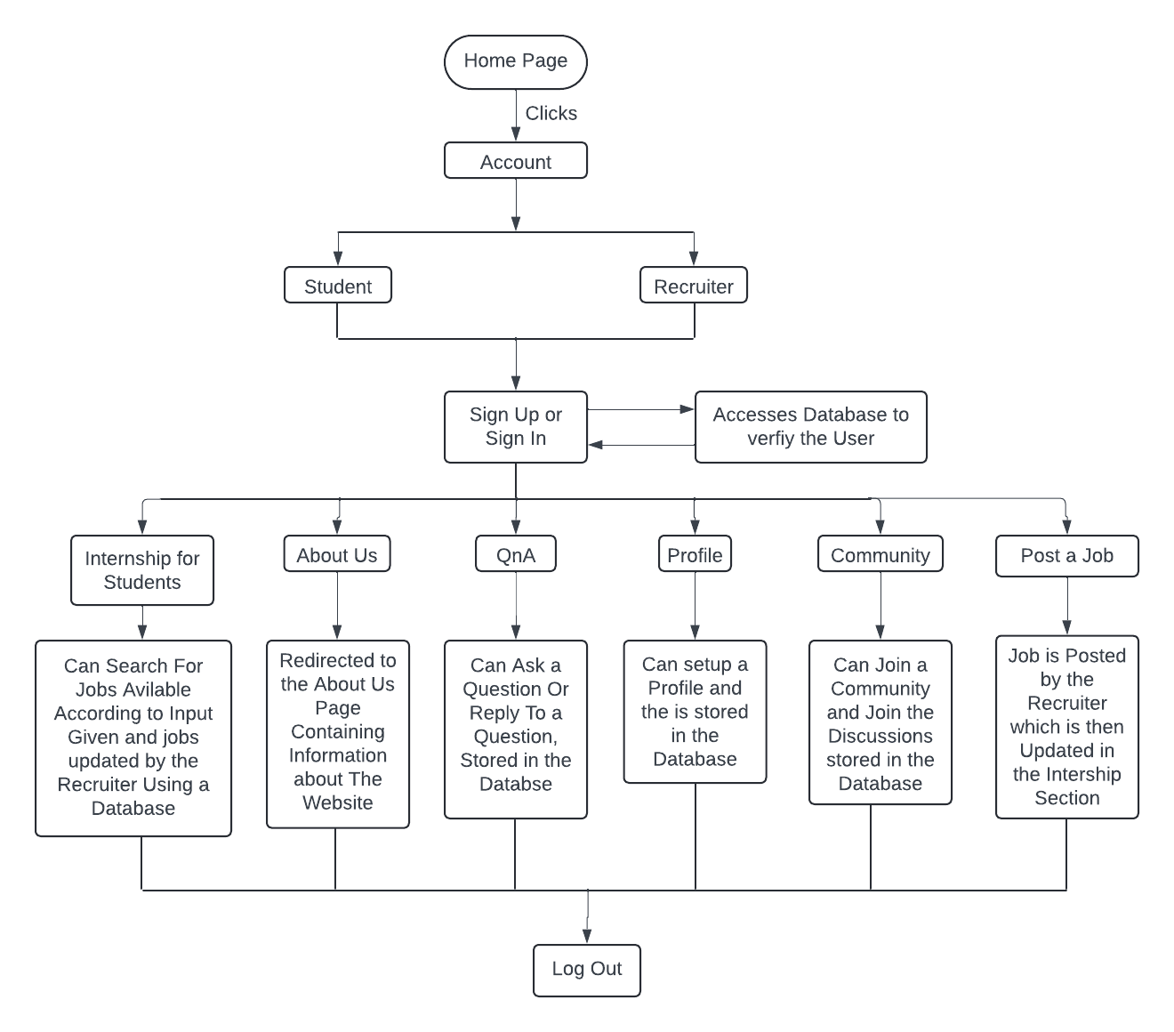

**3.3 Algorithm and Process Design:**

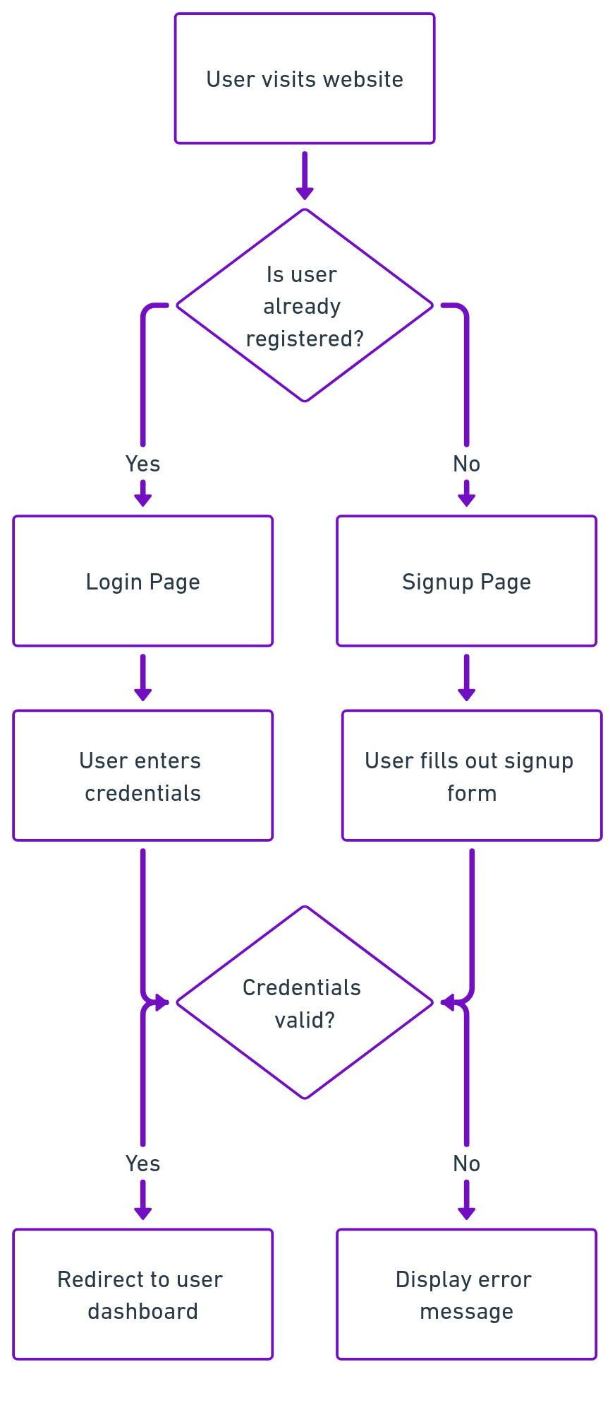

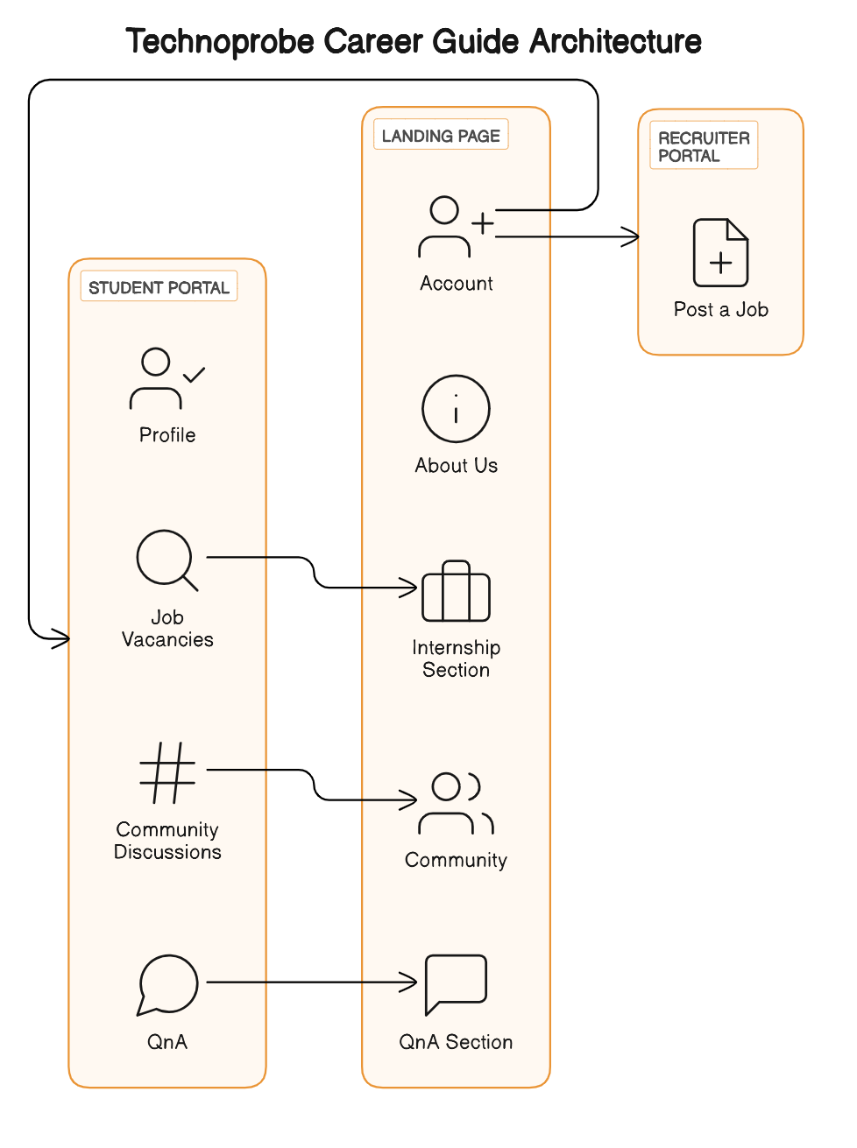

**3.4 Details of Hardware and Software:**

1. Frontend Web Development tools(HTML/CSS/JavaScript)
2. Backend development framework (Flask, Python)
3. Database Management (MongoDB ATLAS)

**3.5 Experiment and Results:**

1. Sign in and Sign up Page

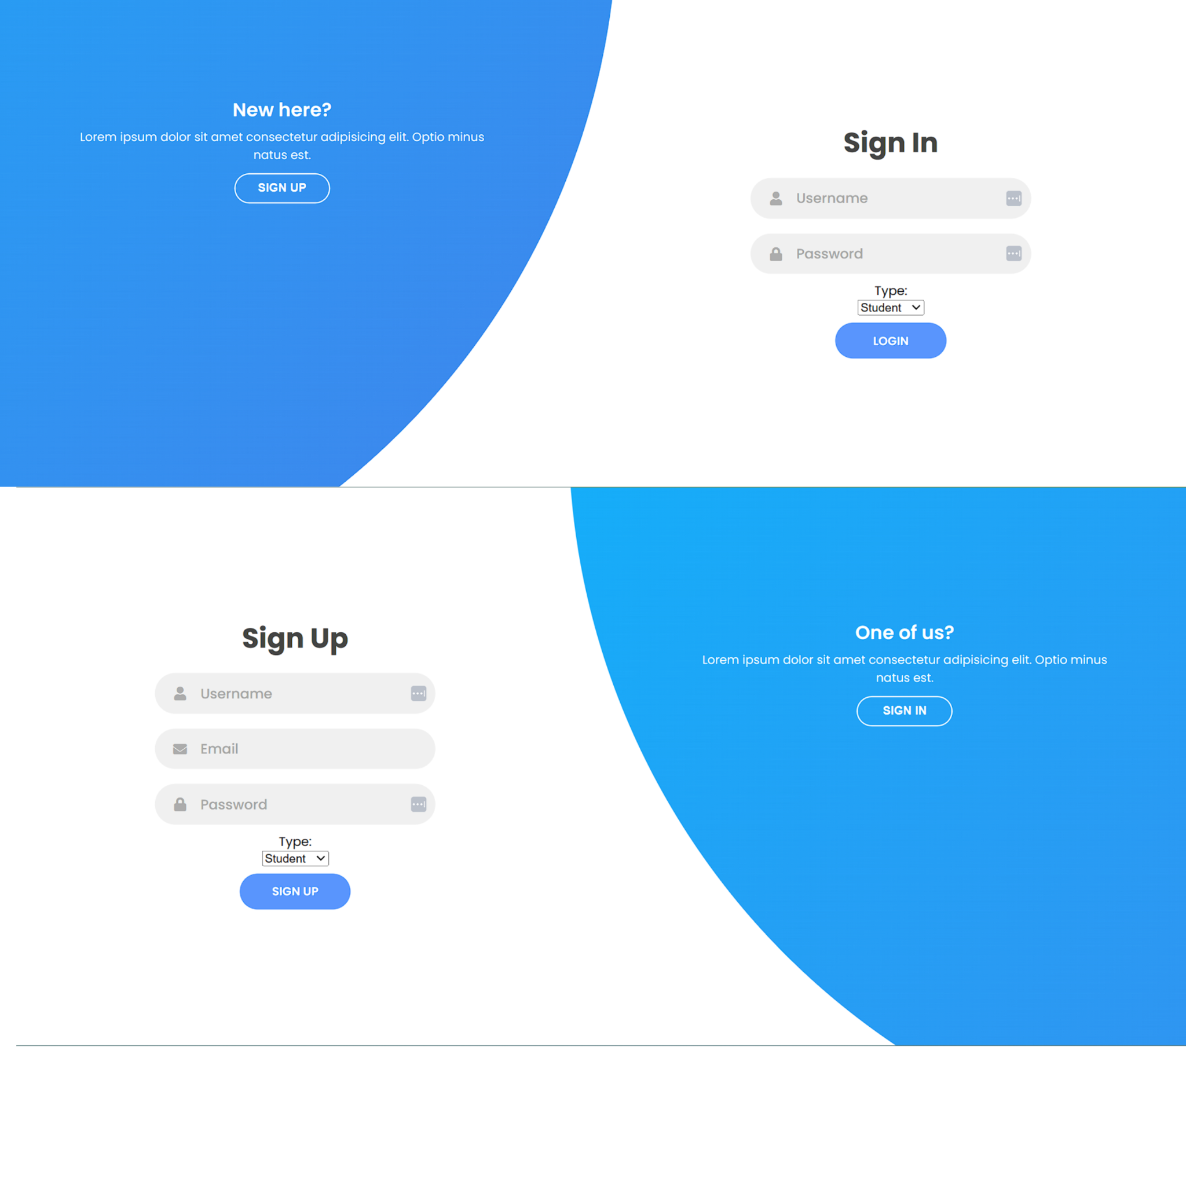

1. Landing Page of Student and Recruiter

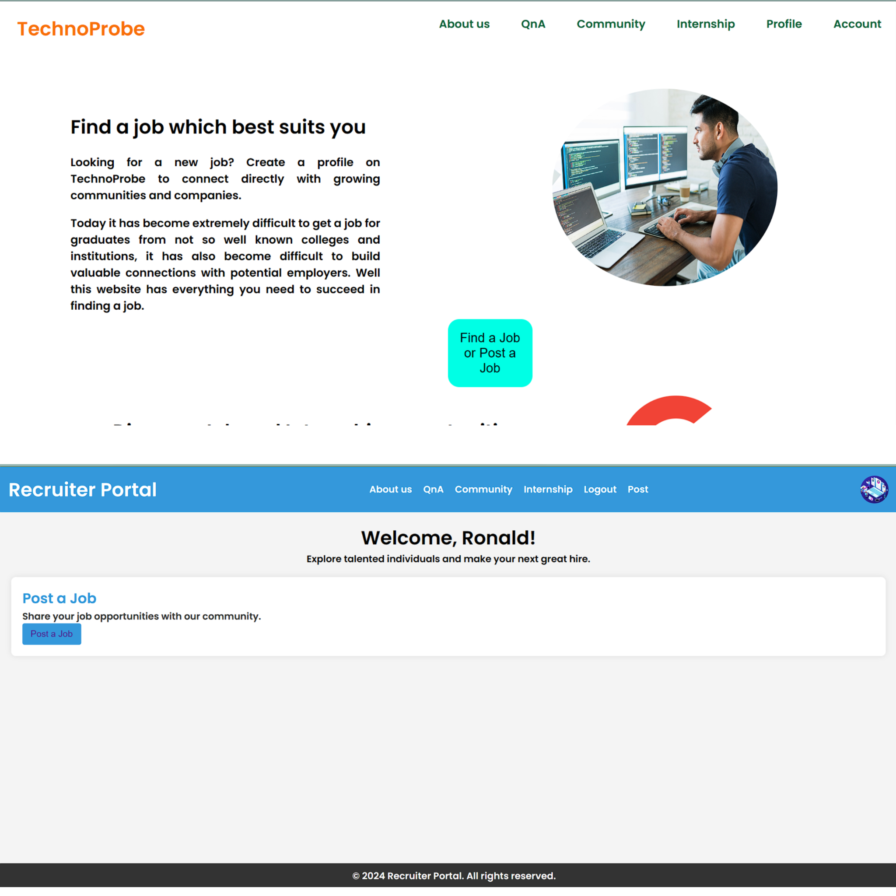

1. Community Section

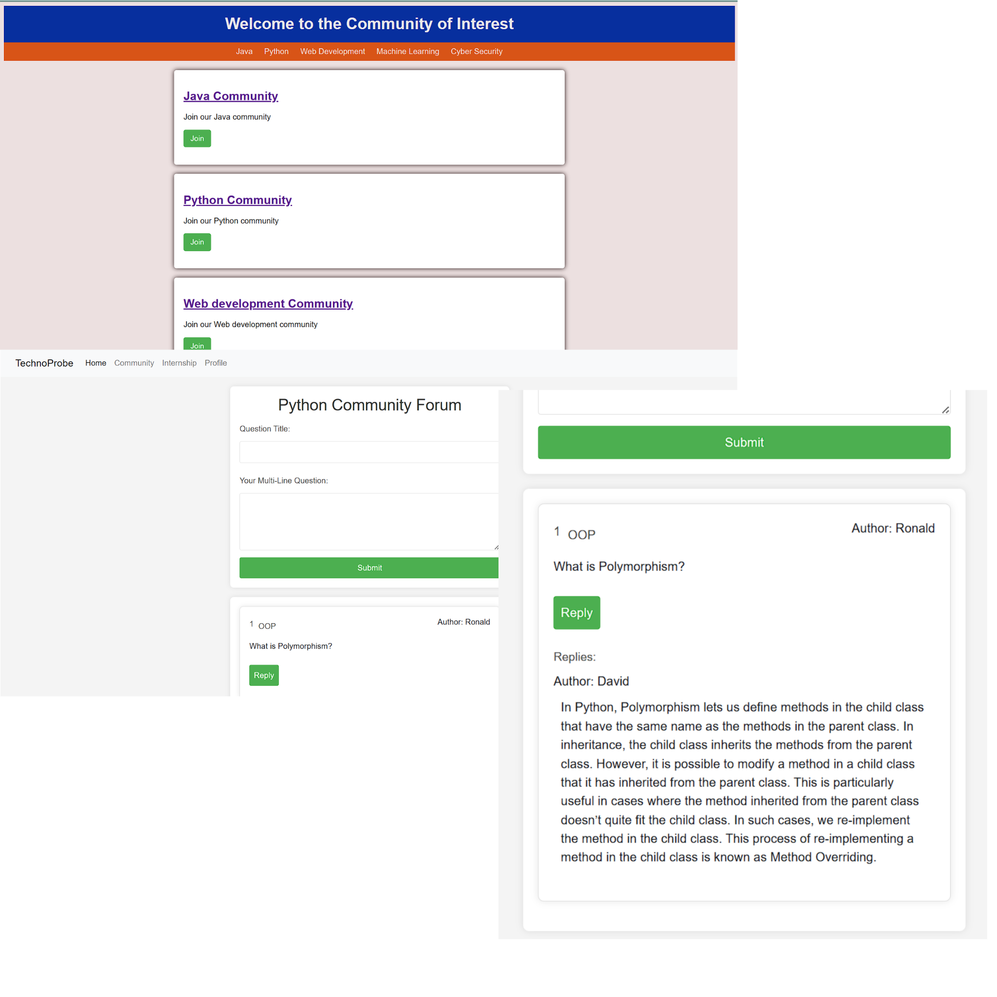

1. QnA and User Profile Section

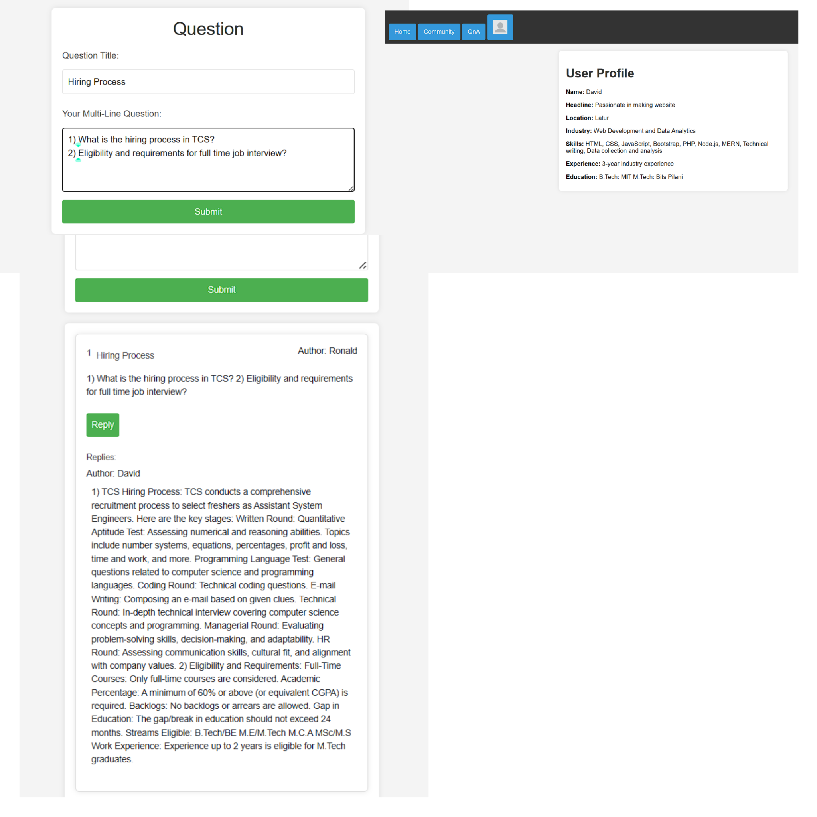

1. Internship Search Section

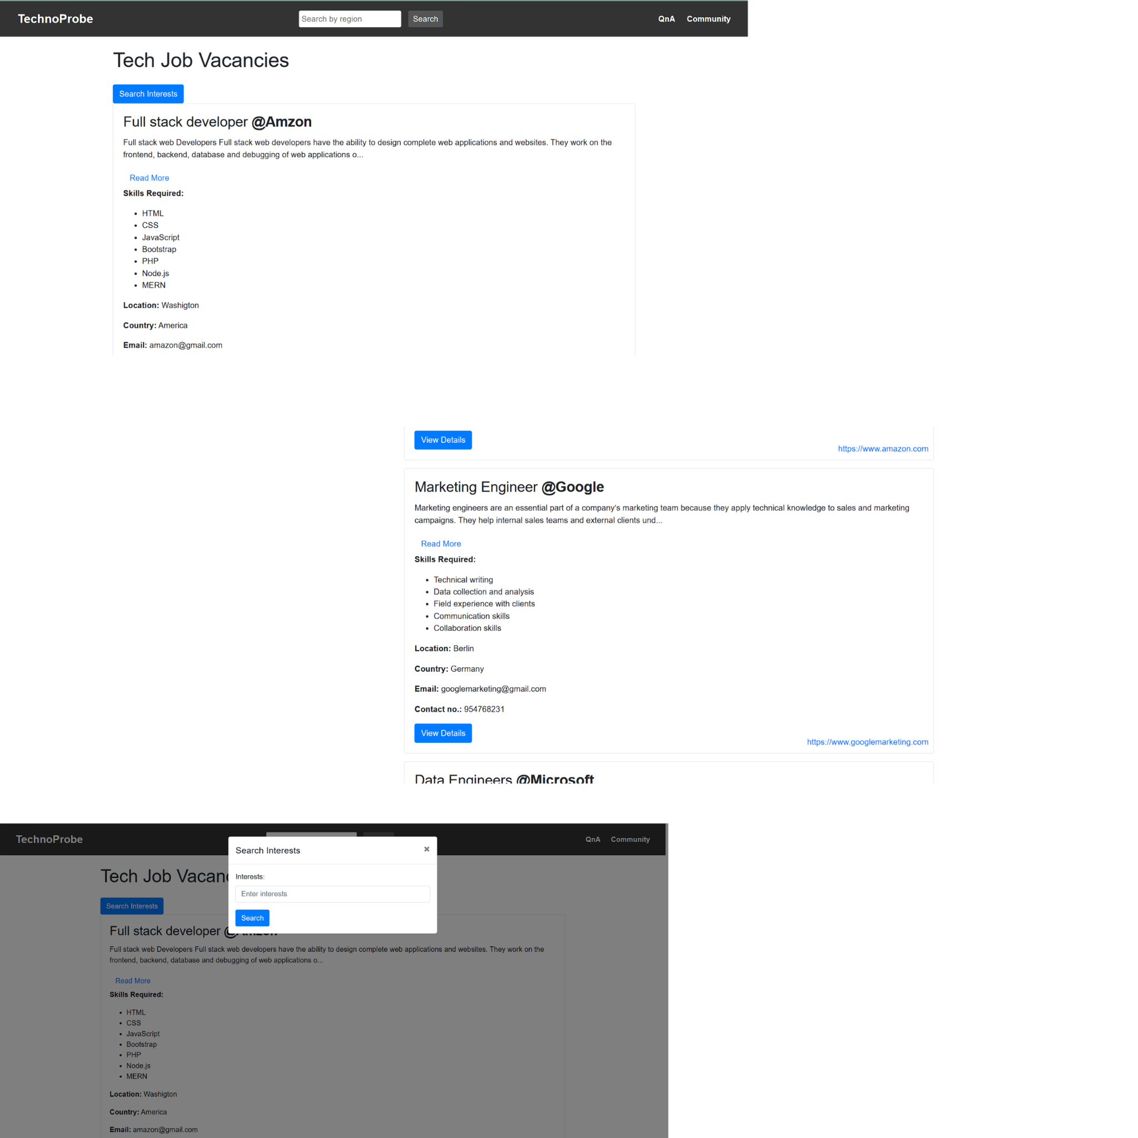

1. Job Posting and Finding Candidates Section

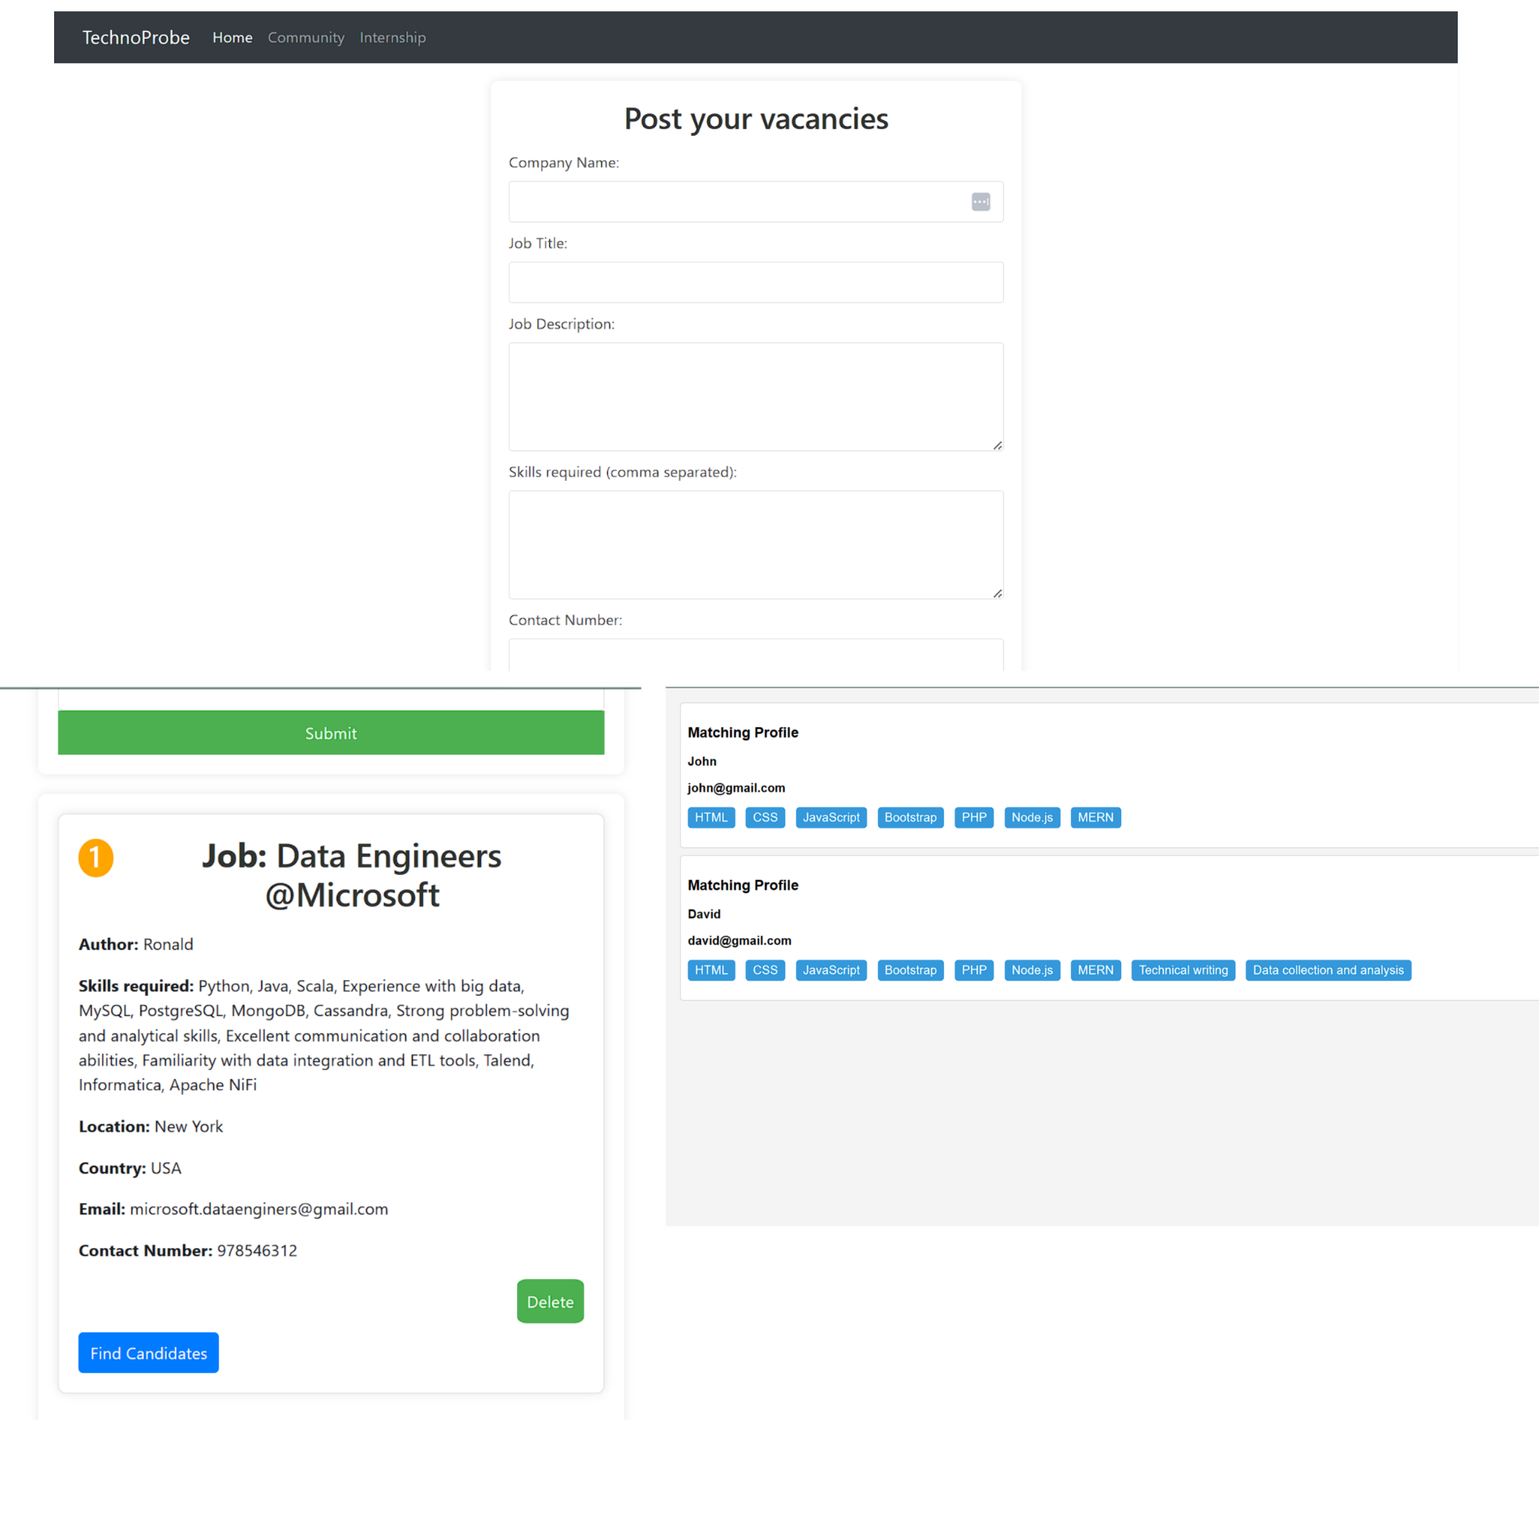

**3.6 Conclusion**

**Conclusion:**

In an era characterized by ever-advancing technology and the need for continuous learning and professional growth, "TechnoProbe: A Career Guide" emerges as a beacon of innovation. This project has been meticulously crafted to address the pressing challenges faced by students, researchers, and professionals in the digital age. The multitude of platforms, each catering to a fragment of one's career needs, has led to information overload and inefficiency. The solution, as we have outlined, lies in creating a unified platform, seamlessly integrating modules that facilitate exploration, internships, and career advancement.

"TechnoProbe" is not merely a website; it is a vision, a dynamic ecosystem that fosters knowledge sharing, career development, and meaningful interactions. By introducing Exploration Collectives, the platform enables interdisciplinary collaborations, offering users access to real-time job updates, internship opportunities, and direct engagement with companies' projects. It empowers individuals to propose their research ideas and thrive in their chosen domains. Moreover, the QnA section serves as a hub for asking questions and seeking guidance, strengthening the learning and research communities.

The "About Companies" section provides detailed insights into company profiles, enabling users to make informed decisions about their career paths. "TechnoProbe" has been designed with the singular goal of simplifying complexities, promoting interactions, and delivering an environment for growth. We firmly believe that all the aspects of career development, education, and skill enhancement can coexist under a single umbrella, and "TechnoProbe" has emerged as the answer to that call.

**References:**

[1] Acar, Y., Backes, M., Fahl, S., Kim, D., Mazurek, M.L. and Stransky, C., You Get Where You're Looking For: The Impact Of Information Sources on Code Security. in Proceedings of the IEEE Symposium on Security and Privacy (SP), (2016), IEEE, 289-305.

[2] Afzal, W., Torkar, R. and Feldt, R. A systematic review of search-based testing for non-functional system properties. (2009). Information and Software Technology, 51 (6). 957-976.

[3] Albrecht, W. D. (2011). LinkedIn for Accounting and Business Students. American Journal of Business Education, 4(10) 39-41.

[4] Boyd D. &Ellison, N. (2007). Social Network Sites: Definition, History & Scholarship. Journal of Computer-Mediated Communication. 13(1).